CAPICOM.DLL has not installed properly
64 Bit OS
1. Open a CMD prompt as Administrator
2. Change Directory to CD c:\windows\sysWOW64\
32 Bit OS
1. Get a DOS prompt
2. Change Directory to C:\windows\system32\
32 & 64 Bit OS
3. see if capicom.dll exists by entering
dir capicom.dll
3a If Capicom.dll does not exist download it from
http://www.microsoft.com/en-US/download/confirmation.aspx?id=25281
4. Enter regsrvr32 capicom.dll
5. You should see a confirmation message
6. Run AisDecoder & see if you still get the ActiveX message
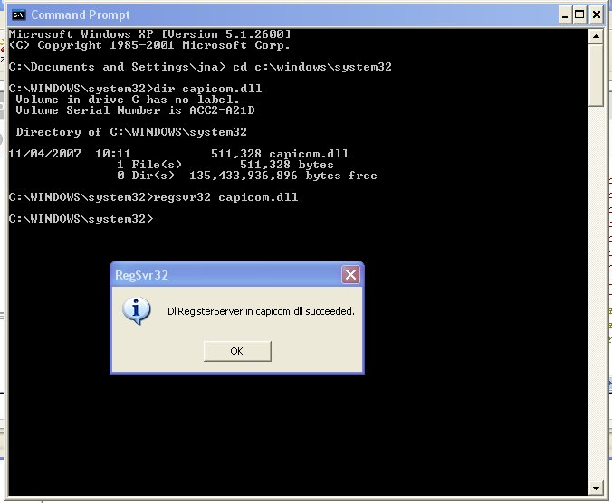
Above is 32 bit example
For further info see http://unmitigatedrisk.com/?p=246

